

|  |
| --- |
| Industry  Innovation  Report |
|  |
| February 5  Team Banksia  Authored by: Rui (Allen) Qin |



**Table of contents**

1. Introduction 1

2. Team expertise 1

3. Methods and approach 2

3.1 Mapping 2

3.2 Sketching 2

3.3 Prototyping 2

3.4 Testing 3

4.Challenge Analysis 3

4.1 Background 3

4.2 Challenge Map 3

4.3 Sketching and Lean Canvas 4

5.Prototype 4

5.1 Key Points of the Prototype: 4

5.2 Innovation and Differentiation: 5

5.3 Economic, Social and Environmental Impact: 5

6.Insight and testing 5

6.1 Suggestions 5

6.2 Limitation 5

7.Recommended and conclusion 6

7.1 Recommendation 6

7.2 Conclusion 6

8. References: 7

9. Appendix: 9

# 1. Introduction

The report focuses on the challenge of developing a report card prototype that highlights companies’ actions towards the 17 sustainable development goals (SDGs). The team worked on this challenge to create a tool that allows Banksia Foundation to easily report on the awardees’ sustainability efforts and progress as well as metrics to measure the unquantifiable content. The report will provide an overview of the report card prototype and its features, as well as the process and methodology used to develop it to demonstrate the thought that went into its development. It will also include feedback from customers that have tested the prototype to ensure its practicality and reliability. The report will be a valuable resource for the Banksia Foundation looking to enhance the understanding of the report card’s prototype.

# 2. Team expertise

|  |  |  |  |
| --- | --- | --- | --- |
| Name | Picture | Roles | Value |
| Rui Qin (Allen) |  | * implement solutions to resolve problems * improve team performance * Project manager | Allen developed a plan that ensured the team hit all their deadlines, and he brought his problem-solving skills and helped to find solutions to the challenge |
| Geoffrey Meng |  | * Identify and analyze complex issues * Generate creative and effective solutions * Leader | Geoffrey brought his strong leadership skills and helped keep the team on track and organized, and he also the producer of the prototype with strong technical skills |
| Lisa Zheng |  | * Ensure teammates work together efficiently and effectively * Presenter | Lisa values collaboration and teamwork and held regular meetings to keep everyone informed and on the same page. |
| Jordan Alofi |  | * Communication between the team and stakeholders * Presenter | Jordan was the main presenter of the project with excellent presentation skills, and he was the main speaker of the stakeholders' conversation. |
| Ian Nguyen |  | * Innovator * Generate new ideas * Think outside the box and challenge | Ian suggested new features for the report kit, provided the idea about the SDGs explainer |
| Made Mahayana |  | * Collaborator * build and maintain positive relationships in the team | Made insured the project run smoothly and successfully, and he provided extra help while the team prepared the presentation. |

# 3. Methods and approach

## 3.1 Mapping

Mapping is a powerful tool for identifying and understanding the problem and target users. The process of mapping involves customer journey maps, stakeholders’ maps and solution maps (Google Ventures, 2014). One of the key benefits of mapping in a Design Sprint is that it facilitates a shared understanding among team members (Brown & Wyatt, 2010). By creating the journey map, the team can identify the problem and know who can get benefit from the report kit from different perspectives, and find solutions that may have been missed otherwise (Brown & Wyatt, 2010).

## 3.2 Sketching

Sketching is used to generate and explore ideas visually, including storyboards, and visual representations of the user experience (Brown & Wyatt, 2010). It is an effective tool because it is fast, low-fidelity, and non-committal (Google Ventures, 2014). Sketching helped the team to create a visual representation of the report prototype solution that can be easily understood. By following the 4 steps of sketching, the team members collected a large amount of information, drew different data visually sketches based on the information and SDGs, combined various indicators and text parts into the report prototype, and continuously determined the details of the report prototype (Knapp & Zeratsky, 2016).

## 3.3 Prototyping

The goal of prototyping is to create a tangible representation of the solution, which can then be tested with users and refined based on feedback (Knapp & Zeratsky, 2016). Prototyping allows teams to test their solutions in a real-world environment without spending a large amount of time and resources on building the report solution for next-step testing (Knapp & Zeratsky, 2016). Furthermore, prototyping allows teams to identify potential barriers to adoption in the report kit and make decisions about how to overcome these challenges (Brown & Wyatt, 2010).

## 3.4 Testing

Testing is an essential aspect that offers validating assumptions, gathering feedback and identifying potential barriers (Knapp & Zeratsky, 2016). The testing program proved that our report kit prototype is effective and satisfactory. And testing provided teams with a deeper understanding of their user and users’ needs, which can help teams to create more effective and user-centred report solutions, identify areas that need improvement and make adjustments for the next stage (Brown & Wyatt, 2010).

# 4. Challenge Analysis

## 4.1 Background

The Banksia Foundation is an Australian-based non-profit organisation dedicated to promoting sustainability and environmental leadership (Banksia, n.d.). The Foundation recognises individuals and organisations that make a positive impact on the environment and communities through their leadership and initiatives (Banksia, 2022). The Foundation’s mission is to create a sustainable future by inspiring, educating and celebrating leadership (Banksia, n.d.). The challenge that the Banksia Foundation faces is to provide its awardees with a report card on their leadership to the UN SDGs. The Foundation recognises the need for greater analysis and support of entrants’ performance in sustainability leadership and wants to provide its awardees with an evaluation of their sustainability performance (Banksia, 2022). The stakeholders’ analysis (Appendix A) provides an overview of the stakeholders that need to be considered in the challenge. The map shows the key stakeholders involved, including the Banksia Foundation, awardees, award sponsors and other stakeholders. The team focused on creating a standardized, user-friendly, and educational report that is easy to produce.

## 4.2 Challenge Map

According to the stakeholders and the team analysis, the challenge map was provided (Appendix B) as a visual representation of the various stakeholders and systems that need to be considered in creating an effective report card for awardees. The challenge map highlights the problems that all award entrants don't receive very comprehensive feedback regarding their performance, and entrants who fail to win are not well recognised even if their initiative and effort are not failures. The challenge map points out that the report card will add value to the Banksia awards and recognise the work of all entrants to motivate them to strive towards enhancing SDGs (Hattie, 2016). The enhancement of the report kit will be based on information from entrants’ performance to drive entrants to make their work further to the UN SDGs (Department, 2022). Moreover, having an open and positive feedback report can strengthen the recall of entrants, making them repeat customers for the Banksia Foundation (Sterling, 2018). In the future, the Banksia Foundation can leverage the report kit to add SDGs consulting services, thereby increasing their offerings and enhancing their impact on SDGs (UN, 2021).

## 4.3 Sketching and Lean Canvas

The sketching (Appendix D) and lean canvas (Appendix E) components of the challenge map provide a visual representation of the various ideas and concepts that have been considered in the process of creating the report card. The team has decided to concentrate on creating a comprehensive report card system that features distinct metrics. This approach will give a precise assessment of the awardees' progress and effect on the SDGs, and it will offer constructive criticism and suggestions while acknowledging their achievements and providing positive feedback on their performance.

# 5. Prototype

This section offers a comprehensive overview of the prototype, highlighting its key features. Additionally, it delves into the unique aspects of the report kit and outlines its economic and environmental impact. The purpose is to provide a clear understanding of the prototype and its significance in the market.

## 5.1 Key Points of the Prototype:

1. Special Indicator: The prototype uses a special indicator graph to show how far the winners are from their best and average performance to visually show their performance.
2. SDG Explainer: A summary of the awardee's progress towards each SDG with strengths and weaknesses of the organisation. This section will provide a detailed description of the awardee's actions, as well as explaining that why these actions have had on the advancement of the SDG, and how the action can be improved.
3. Customizable Content: The report card will allow the awardee to customize the content to match their specific sustainability initiatives and goals. This will enable the awardee to focus on their specific strengths and areas for improvement.
4. Standard report framework design: This report utilizes sustainable development reporting tools such as G4 and the company's SRT to emphasize the capture of a wide range of values and measure the company's performance across the three pillars of sustainable development: economic, social, and environmental (Renard, 2015). Additionally, the report highlights the company's commitment to sustainability and responsible corporate citizenship, as demonstrated through its ongoing efforts to balance economic growth with environmental preservation and social progress (Indra, 2022).
5. Benchmarking: The report card will provide the awardee with benchmarking information, allowing them to compare their performance to other organisations in their industry. This will enable the awardee to identify best practices and areas for improvement.
6. Certification: Each organisation should receive a certificate of recognition, graded to highlight the stage of the organisation's contribution to the SDGs, showing that they are making progress towards achieving the SDGs, even if they do not win. In addition, the certificate adds value to the award (Inge, 2017).

## 5.2 Innovation and Differentiation:

The report card stands out due to its combination of qualitative and quantitative benchmarking data, enabling the award recipient to compare their performance to peers in their industry. The accompanying SDG explainer document serves an educational purpose by helping organisations comprehend the impact of their actions on the SDGs and helping them clarify ambiguous concepts about SDGs (Giselle, 2018). Additionally, the issuance of certificates will acknowledge the efforts of all entrants and inspire them to incorporate the SDGs into their work, as well as encourage their participation in future award phases where they will receive updated reports that will help improve their performance (Inge, 2017).

## 5.3 Economic, Social and Environmental Impact:

The report card will help the awardee to prioritize their sustainability initiatives, identify areas for improvement, and engage with stakeholders. The report card will also provide valuable information for the Banksia Foundation, enabling them to evaluate the impact of their awards and identify best practices for promoting sustainable development. Therefore, the report card increases the value of the award, which means it can promote more practitioners and companies to be the entrants, and let the entrants who fail to participate in the next round award.

# 6. Insight and testing

Our research and testing helped us identify areas for improvement and validate new ideas. Gathering insights from surveys and interviews with 5 customers, including awardees, stakeholders, and sustainability experts gave us positive feedback and validated our idea, boosting team confidence. However, they also provided suggestions for improvement.

## 6.1 Suggestions

1. Customers highlighted the importance of a shared global language in health and safety reporting. A research article and customer feedback pointed to the use of the UN SDGs as a basis for reporting consistency (O’Neill, 2011). This insight will guide our prototype iteration by incorporating the UN SDGs terminology and metrics.
2. Customers suggested a human-centric approach to communication, which was reinforced by a Science Direct paper emphasizing the use of constructive language (Carlton, 2018). One customer recommended using the reporting language of the APCO as a model. This insight will shape our prototype iteration by using language that is sensitive and respectful of organisations' areas for improvement. For example, changing the “weakness" to "areas of improvement".

## 6.2 Limitation

It is important to acknowledge Prototype testing limitations. The following are some of the limitations during the testing of the prototype.

1. Limited Sample Size and Time: The limited sample size of 5 customers in the prototype testing may not accurately reflect everyone's feedback, this will lead to a wide range of opinions and uncertain results (Faber, 2014), which can result in less reliable data and a higher chance of making mistakes (Chris, 2018). To improve this, it is suggested to gather feedback from all award entrants after future awards. Additionally, the limited time frame of a week for prototype testing may impact the results, which may cause missing important details and errors. To address this, it is recommended to extend the testing time to enable a more comprehensive evaluation of the report's impact on the entrants and their alignment with the UN SDGs.
2. Limited Feedback: The feedback received from users was limited, which may have affected the results. To overcome this limitation, it is recommended to gather feedback from a more comprehensive and diverse group of entrants (Sarah, 2021). This will help to ensure a more representative and accurate understanding of the entrants’ needs and preferences. By incorporating a wider range of perspectives, the team can further improve and refine the report to better meet the needs of its intended audience.

# 7. Recommended and conclusion

## 7.1 Recommendation

1. Developing a monitoring and evaluation framework: The Banksia Foundation could create a comprehensive monitoring and evaluation framework to measure the impact of the report on their awardees' leadership on the advancement of the UN SDGs. This framework could incorporate various data sources such as annual reports, sustainability reports, stakeholder feedback and data analytics tools.
2. Implementing the report card: Creating a comprehensive database system that houses best practices and successful case studies. This report card system can be shared with awardees and stakeholders, allowing them to track their progress and assess areas of improvement. The Banksia Foundation can also use this database to monitor the performance of entrants and determine how the report card has impacted their sustainability efforts.

## 7.2 Conclusion

In conclusion, the report details the development of a report card prototype to highlight companies' actions towards the SDGs. The team used mapping, sketching, prototyping and testing methods to create a report kit that is standardized, user-friendly, reliable and effectively measures the unquantifiable content. The report card prototype was developed to help the Banksia Foundation report on the awardees' sustainability efforts and progress. Feedback from customers who tested the prototype showed that the report card is effective and satisfactory. The report provides valuable insights and a comprehensive overview of the development process and methodology used to create the report card prototype, making it a valuable resource for the Banksia Foundation and providing a practical solution to its challenge.

# 8. References:

Methods and approach:

Brown, T., & Wyatt, J. (2010). Change by Design: How Design Thinking Transforms Organisations and Inspires Innovation.

Google Ventures. (2014). Design Sprint. Retrieved from: [Share and engage with the Design Sprint Community (designsprintkit.withgoogle.com)](https://designsprintkit.withgoogle.com/methodology/overview)

Knapp, J. & Zeratsky, J. (2016). Sprint: How to Solve Big Problems and Test New Ideas in Just Five Days

Challenge Analysis:

Banksia Foundation. (n.d.). About Us. Retrieved from [About Us - Banksia Foundation (banksiafdn.com)](https://banksiafdn.com/about-us/)

Banksia Foundation. (n.d.). Main Page. Retrieved from [Home - Banksia Foundation (banksiafdn.com)](https://banksiafdn.com/)

Banksia Foundation. (2022). Challenge Brief_Graz_Banksia Foundation. Retrieved from: Appendix G (Challenge Brief_Graz_Banksia Foundation)

VIC, Department, of, Education., (2022). Feedback and reporting. Retrieved from: [Feedback and reporting (education.vic.gov.au)](https://www.education.vic.gov.au/school/teachers/teachingresources/practice/Pages/insight-feedback.aspx#:~:text=Purpose%20of%20feedback,the%20learning%20intentions%20or%20goals.)

Hattie, J., & Timperley, H. (2016). The Power of Feedback. Retrieved from: [The Power of Feedback - John Hattie, Helen Timperley, 2007 (sagepub.com)](https://journals.sagepub.com/doi/full/10.3102/003465430298487)

Sterling, Bone., Katherine, Lemon., Clay, Voorhees., Katie, Liljenquist., Paul, Fombelle., Kristen DeTienne., R, Bruce. (2018). The Power of Surveys to Increase Repeat Business. Retrieved from: [Keller Center for Research | Baylor University](https://www.baylor.edu/business/kellercenter/news.php?action=story&story=194666)

UN. (2021). Consultations on Climate and SDG Synergies for a Better and Stronger Recovery from the Covid-19 Pandemic. Retrieved from: [Consultations on Climate and SDG Synergies for a Better and Stronger Recovery from the Covid-19 Pandemic.pdf (un.org)](https://sdgs.un.org/sites/default/files/2021-07/Consultations%20on%20Climate%20and%20SDG%20Synergies%20for%20a%20Better%20and%20Stronger%20Recovery%20from%20the%20Covid-19%20Pandemic.pdf)

Prototype:

Inge, Black., Christopher, Hertig., Ann, Trinca. (2017). Chapter 8 - The Power of Certification. Retrieved from: [The Power of Certification - ScienceDirect](https://www.sciencedirect.com/science/article/pii/B9780128038178000134#:~:text=The%20power%20of%20certification%20rests,and%20how%20you%20see%20yourself.)

Giselle, Weybrecht. (2018). Why the Sustainable Development Goals Matter to Your Business School. Retrieved from: [Why the SDGs Matter to Your Business School | AACSB](https://www.aacsb.edu/insights/articles/2018/04/why-the-sustainable-development-goals-matter-to-your-business-school)

Indra, Abeysekera. (2022). A framework for sustainability reporting. Retrieved from: [A framework for sustainability reporting | Emerald Insight](https://www.emerald.com/insight/content/doi/10.1108/SAMPJ-08-2021-0316/full/html#sec001)

Renard, Y.J., Siew. (2015). A review of corporate sustainability reporting tools (SRTs). Retrieved from: [A review of corporate sustainability reporting tools (SRTs) - ScienceDirect](https://www.sciencedirect.com/science/article/pii/S0301479715302620)

Insight and testing:

O’Neill, S., Clarke, K., & Flanagan, J. (2011). Are managers of large firms accountable to stakeholders for the financial paradox of OHS risk. Retrieved from: [**Are managers of large firms accountable to stakeholders for the financial paradox of OHS risk — Macquarie University (mq.edu.au)**](https://researchers.mq.edu.au/en/publications/are-managers-of-large-firms-accountable-to-stakeholders-for-the-f)

Carlton, J, Fong., Diane, L, Schallert., Kyle, M, Williams., Zachary, H, Williamson., Jayce, R, Warner., Shengjie, Lin., Young, Won, Kim. (2018). When feedback signals failure but offers hope for improvement: A process model of constructive criticism. Retrieved from: [When feedback signals failure but offers hope for improvement: A process model of constructive criticism - ScienceDirect](https://www.sciencedirect.com/science/article/abs/pii/S1871187117301529)

Faber, J., Fonseca, LM. (2014). How sample size influences research outcomes. Retrieved from: [How sample size influences research outcomes - PMC (nih.gov)](https://www.ncbi.nlm.nih.gov/pmc/articles/PMC4296634/#:~:text=Too%20small%20a%20sample%20may,that%20are%20not%20clinically%20relevant.).

Chris, Deziel. (2018). The Effects of a Small Sample Size Limitation. [The Effects of a Small Sample Size Limitation | Sciencing](https://sciencing.com/effects-small-sample-size-limitation-8545371.html)

Sarah, B., & BellJasmine, WW. (2021).The Importance of Valuing Diversity Within Research. [The Importance of Valuing Diversity Within Research | Diverse: Issues In Higher Education (diverseeducation.com)](https://www.diverseeducation.com/stem/article/15109706/the-importance-of-valuing-diversity-within-research#:~:text=Diverse%20participants%20inform%20research%20results,who%20they%20can%20identify%20with.)

# 9. Appendix:

Appendix A (Stakeholder’s analysis)

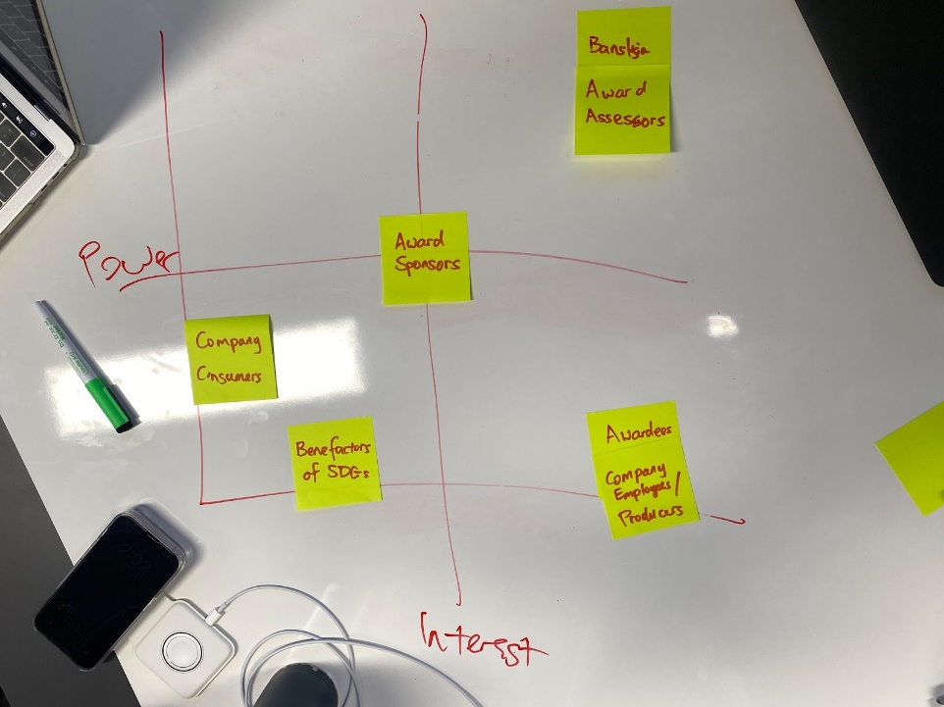

Appendix B (Challenge Map: The main finding is the report enhances the value of the award, acknowledges the efforts of participants, and streamlines the judging process in terms of speed and accuracy)

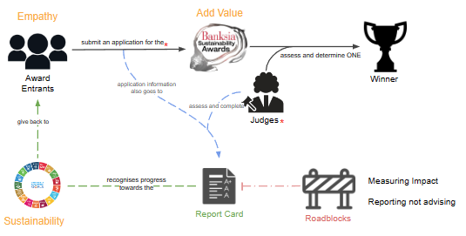

Appendix C (Flow chart: The process of awarding prizes was explained. The main finding is that the report kit will see entrants in continuous competition for banksia awards )

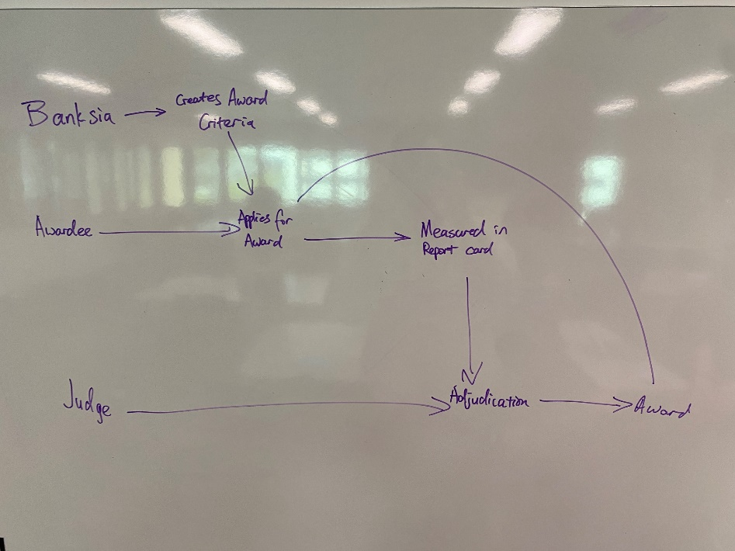

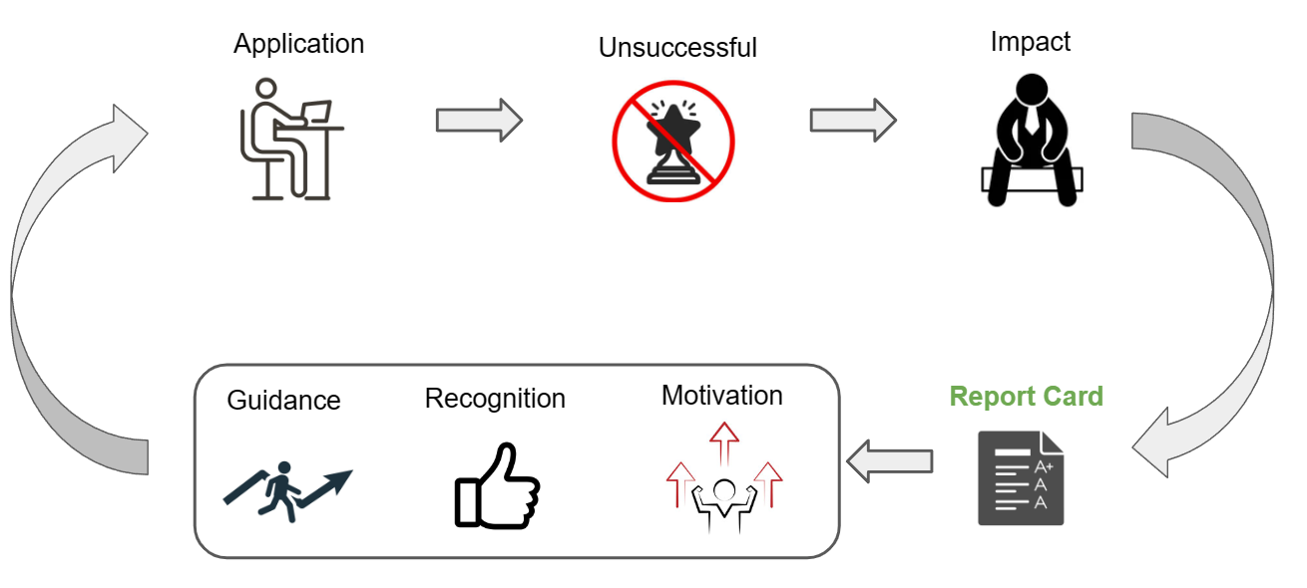

Appendix D (Final sketching)

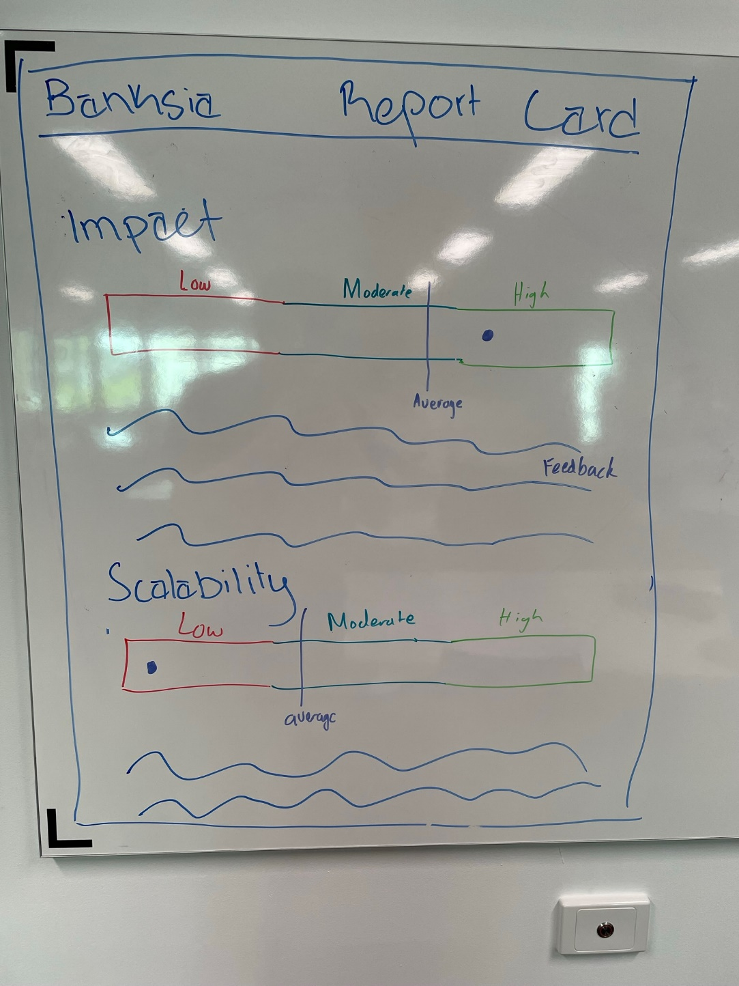

Appendix E (Lean canvas)

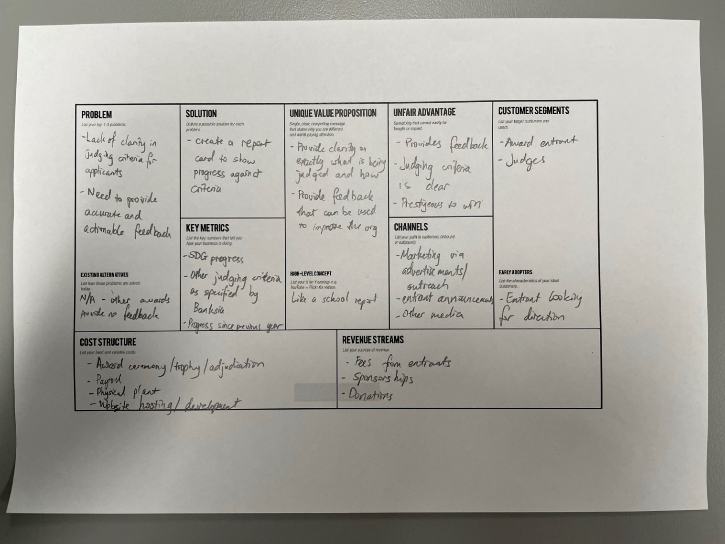

Appendix F (prototype)

Appendix F.1 (Report card)

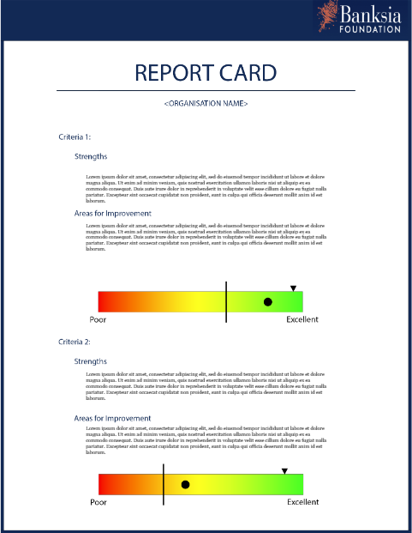

Appendix F.2 (criteria indicator)

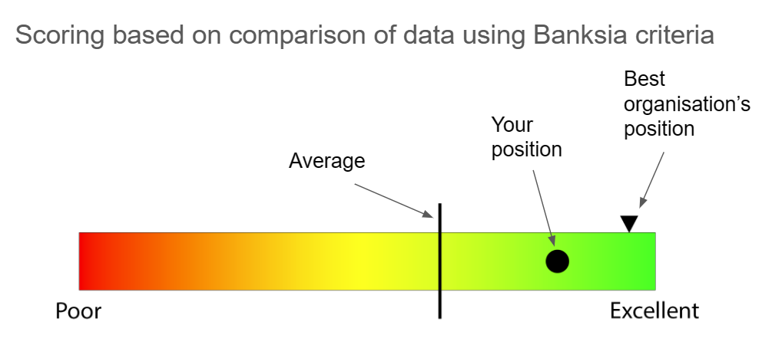

Appendix F.3 (SDGs explainer)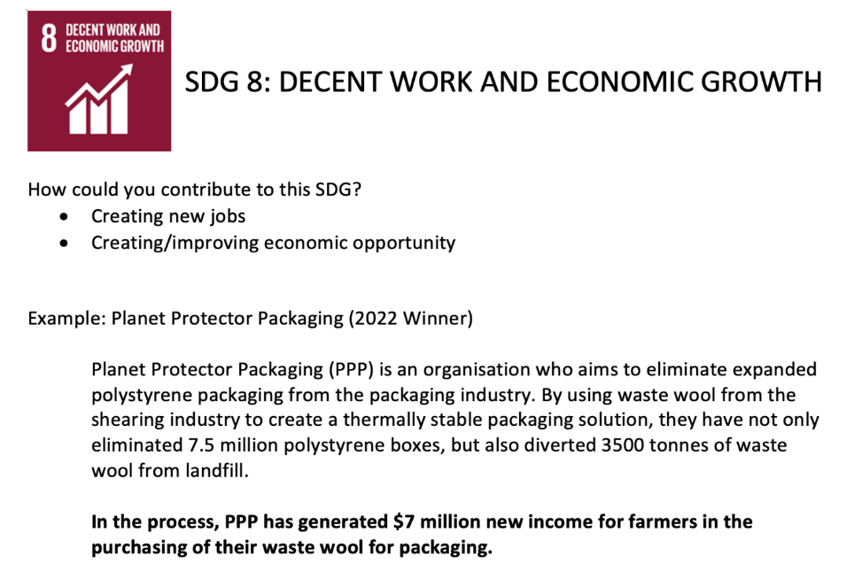

Appendix F.4 (certificate)

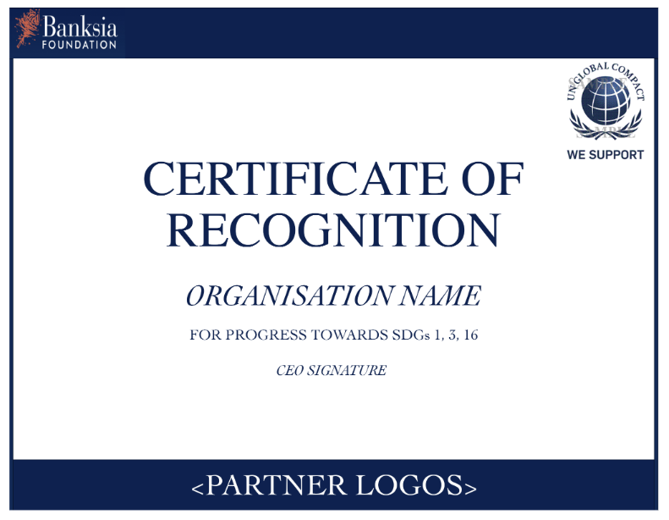

Appendix G (Challenge Brief_Graz_Banksia Foundation)

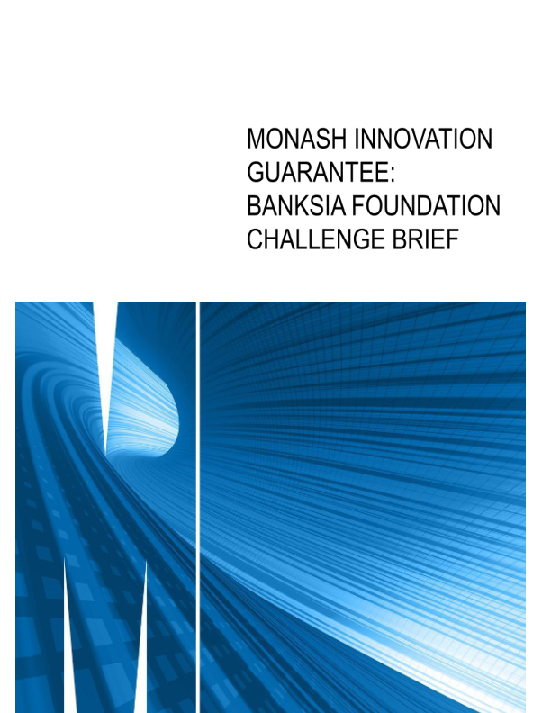

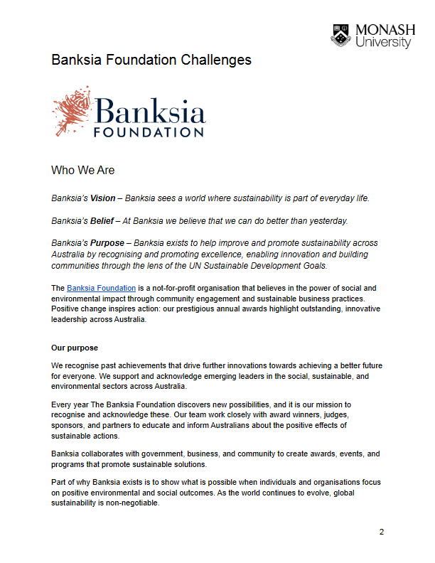 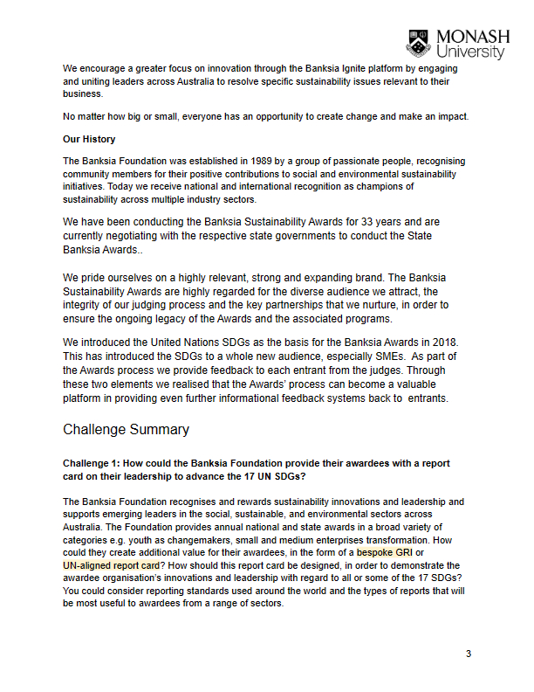 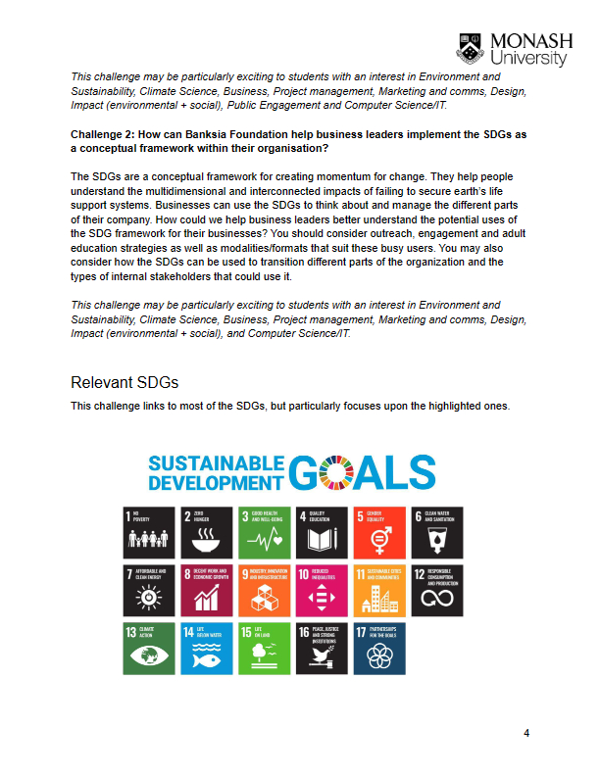 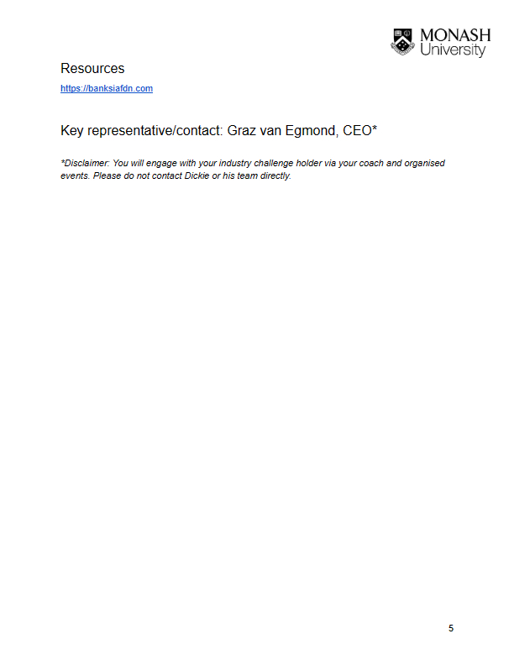

Appendix H (Team Collaboration Agreement)

